* Android **GridView**

*Android****GridView****shows items in two-dimensional scrolling grid (rows & columns) and the grid items are not necessarily predetermined but they automatically inserted to the layout using a****ListAdapter***

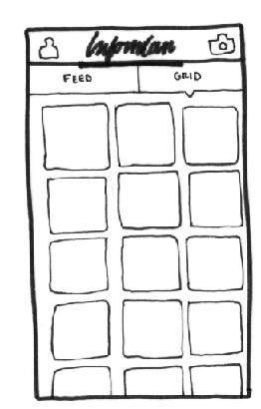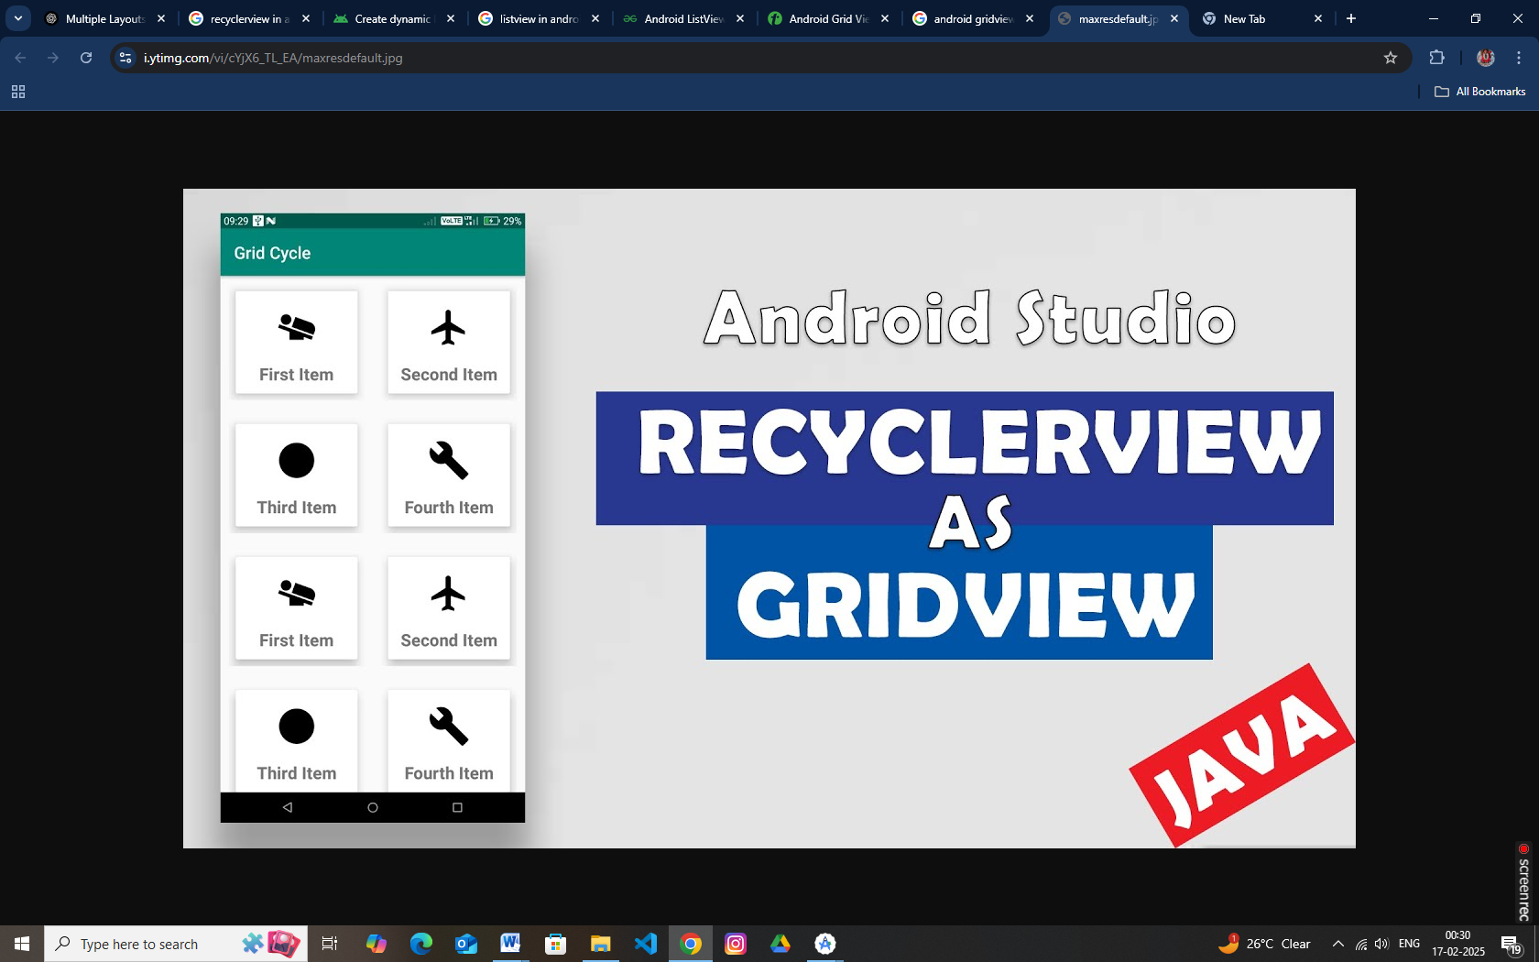

*An adapter actually bridges between UI components and the data source that fill data into UI Component. Adapter can be used to supply the data to like spinner, list view, grid view etc.*

The **ListView** and **GridView** are subclasses of **AdapterView** and they can be populated by binding them to an **Adapter**, which retrieves data from an external source and creates a View that represents each data entry.

**GridView Attributes**

Following are the important attributes specific to GridView –

|  |  |
| --- | --- |
| **Sr.No** | **Attribute & Description** |
| 1 | **android:id**  This is the ID which uniquely identifies the layout. |
| 2 | **android:columnWidth**  This specifies the fixed width for each column. This could be in px, dp, sp, in, or mm. |
| 3 | **android:gravity**  Specifies the gravity within each cell. Possible values are top, bottom, left, right, center, center_vertical, center_horizontal etc. |
| 4 | **android:horizontalSpacing**  Defines the default horizontal spacing between columns. This could be in px, dp, sp, in, or mm. |
| 5 | **android:numColumns**  Defines how many columns to show. May be an integer value, such as "100" or auto_fit which means display as many columns as possible to fill the available space. |